**D-Covid**

1. Submission Name: D-Covid
2. Short Description:

Social Distance monitoring in your workspace using Deep Leaning.

1. Demo Video: Attached
2. Problem Statement: In the current Covid Scenario, it’s a mandate to track and follow the social distancing norms in order to prevent the spread of coronavirus in the near future.
3. Architecture:

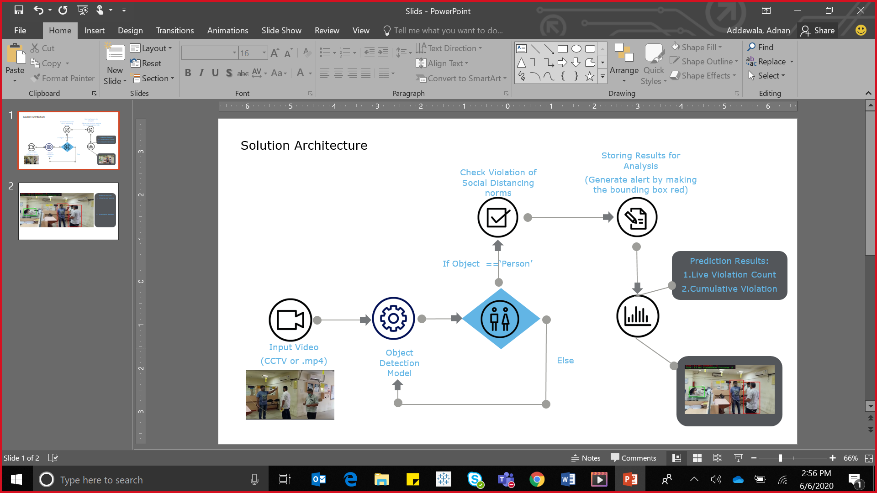

1. Long description:

Our solution aims to address the current scenario of social distancing by generating alerts when there is a breach in the threshold, across areas of social gathering such as office premises, restaurants, malls etc. The solution is built using Computer Vision and Artificial Intelligence to monitor different aspects such as human detection and congestion analysis to ensure maximum public safety using existing visual surveillance system.

To achieve this:

* Data used for Testing: Indoor premises of work place
* Model: MobileNet_SSD
* Condition: 2 Meter is set as a threshold as a violation of Social Distancing Norms
* Output:
  + Violation for a particular time frame(Currently set at 1 sec)
  + Cumulative Violation(Total Violation)

1. Road Map:

Current Scenario:

Our Model is successfully detecting instance where social distancing is violated based on a given threshold.

Steps ahead:

* 1. Integrate the solution with live video feeds (CCTV) and generate hourly report of number of defaulters.
  2. Integrate live feeds capturing the same view but from a different angle and then improve accuracy of detecting defaulters
  3. Add a feature of detecting humans not wearing mask
  4. Highlighting those sections of area under surveillance where most violations have been detected.
  5. To build a customized web application that can assist user to set various parameters to generate report and alerts.